Name: _____________________________________________
Size | Small | Med | Large | XL | XXL
Quantity

Total: __________________ Cash Check #___________
2014 Homecoming Shirt $10
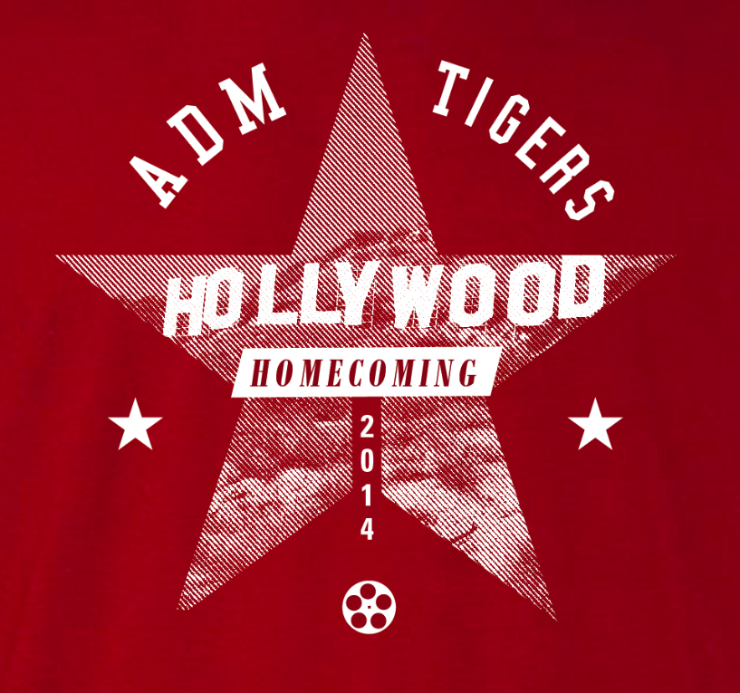

Advisor: __________________________ Grade: _________

